Boston City Parking Ticket to Restaurant Correlation

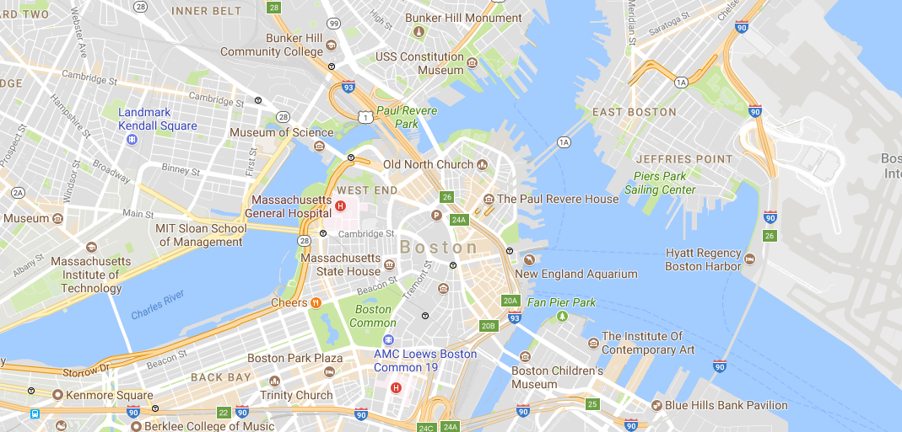

The intent:

The intent of this project is to use the required tools specified in the Judging Criteria to product valuable, actionable intelligence so that consumers of this report can make better decisions regarding the Dinner Out Plans.

The process:

The general process was to use the 311 calls logged into the city of Boston. 57K parking tickets were handed out between Sep 2012 and Jun 2017.

The proposed steps to produce the final product:

1. Extract and Load the Boston 311 Call Data to a spreadsheet.
   1. Access data thru the link provide inSlack
2. Analyze the data
   1. Review the complaint types. Choose a complaint that would yield actionable insights.
   2. Correlate this complaint type with a business type found in Foursquare.
   3. Collaborate with team members using IBM DSX Collaborator option.
3. Report what we found is some form
   1. Use Foursquare map
   2. Relate parking ticket density to geo location
4. Present the method and our findings
   1. Findings
   2. Conclusions
   3. Future to explore

We generalized the geo coordinates down to two decimal points. By assigning the sum of tickets in this grid, we then show the percentage of the total tickets in each cell.

Using FOURSQUARE we were able to show the restaurants within these grids.

Using SDX, were were able to share and collaborate this project with all team members using ………

VALUE:

The value that this product provides is an empirical guide to restaurants and traditional high parking ticked areas. The user can factor this into their dining plans, by perhaps adding time to secure legal parking in a lower parking ticket quadrant.

By focusing upon the proportion of tickets handed out during this time frame in the geographic areas we can provide the consumer of this data with guidance as to the expected level of effort that they may have to consider.

Re-Use Opportunities:

This general reusable approach, is to link recurring event types to geo location coordinates and derive inferences about this pattern phenomena.

For Example:

Parking Ticket Density to Restaurant.

Assumptions:

1_ No one deliberately seeks parking tickets

2_ This is Risk, Reward Dilemma

Higher ticket areas may mean:

Greater competition for the limited number of parking slots. This is high demand that outstrips parking supply.

Inferences:

People are risking a parking ticket because the expectation of reward is high.

Conclusion:

1_This is a great place to eat.

2_This is a real hassle to eat here.

These are the restaurants that we found in the highest density coordinate:

In this geo location latitude = 42.2957, longitude = -71.0617

, we found … parking tickets which is % of the total tickets

* Eddy's Auto Repair Irving

* Keaney funeral home

* Flora's Beauty Supply

* black star books

* O'Brien's Market & Deli

* Gadget Repair King Wireless

* Gibson Playground

* Bugaboo Creek Steak House

* Anh Hong

* Hemenway Park

* Boston Eyeworks

* 7-Eleven

* The Henderson Inclusion School

* Phuong's Hair Salon

* Bernard P. Casey Field

* Rosa's Liquors

* Caitlin & Tessa's

* Dr. William W. Henderson Inclusion Elementary School

